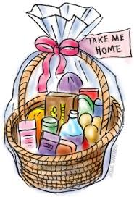

Hotdog supper $3 (includes drink and cookie)

Additional hotdogs $2

Please pre-pay on school-day.com

**Meet your child’s teacher and see the classroom**

Remember to visit the Parent Council table!

There will be raffle tickets and other items for sale!

Thursday September 26

5-7 pm

**FOLEY’s**

**Open house**