Foley Catholic School

MAY 2019

https://fol.schools.smcdsb.on.ca

Principal: Ms. T. Moreau Office Administrator: Mrs. B. Gavin

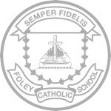
PRINCIPAL’S MESSAGE

There is a “spring” in our step as the weather finally warms and the world becomes fresh and new. Our students are rejuvenated as they enjoy the sunshine and outdoors again! April went by so quickly and included several school events, some of which included First Reconciliation and First Communion, the season start for our co-ed junior basketball and co-ed volleyball teams, several field trips and our monthly School Mass. Our PALS program is up and running again and there are many special theme days planned for May.

This coming month, devoted by the Catholic Church to Mary, is always a busy one in Catholic Schools. With Catholic Education Week happening during the second week of May there are several activities taking place. We will be celebrating Mass at Guardian Angels Church in Orillia on Saturday, May 4 with all of our community of schools in the Orillia area at the 5 pm Mass. Our students will be participating in the Mass in many capacities, such as Altar servers, Choir and bringing the Gifts to the altar. We also have many special events planned for the week at the school such as Music Monday, our Social Justice Walk, Math Games Day, our annual Talent Show and Pitch In week. The Grades 3 and 6 students will also be participating in the EQAO assessments during the last 2 weeks of the month. Please see the calendar of important May dates for specific dates.

On behalf of the staff, I extend our best wishes to all mothers, grandmothers and great-grandmothers on the occasion of Mother’s Day. May Mary, our Mother, continue to watch over us as we honour her in the month of May.

God Bless.

Prayer for May-The month of the Virgin Mary

Hail, most gracious Mother of mercy, hail, Mary, for whom we fondly yearn, through whom we obtain forgiveness! Who would not love thee? Thou art our light in uncertainty, our comfort in sorrow, our solace in the time of trial, our refuge from every peril and temptation. Thou art our sure hope of salvation, second only to thy only-begotten Son; blessed are they who love thee, our Lady! Incline, I beseech thee, thy ears of pity to the entreaties of this thy servant, a miserable sinner; dissipate the darkness of my sins by the bright beams of thy holiness, in order that I may be acceptable in thy sight.

Upcoming Events

Wed. May 1 – Volleyball tournament at OSS
1:00-4:00 p.m.

Thurs. May 2 – Bananas in Pajamas

Fri. May 3 – PA Day

May 6-10 – Catholic Education Week

Tues. May 7 – Parent Council Meeting at
5:00 p.m.
- Social Justice Walk

Wed. May 8 – Math games day

Thurs. May 9 – Talent show and
Music Monday Song

Fri. May 10 – Yard clean up

Tues. May 14 – Vision Screening (SK)

Wed. May 15 – Silver Birch field trip

Fri. May 17 – Mass at Church 10 a.m.

Mon. May 20 – Victoria Day - No School

May 21-23 – Grade 3 EQAO

May 27-29 – Grade 6 EQAO

Fri. May 31 – Student Assembly 10 a.m.

Thank you to the many parents that have signed up for School-Day.
Field trips, food orders and announcements will all be done through School-Day. If you haven’t signed up yet please do as soon as possible to avoid missing out on anything!
If you have already signed up and are not receiving email notifications for new products and events, please go into your settings and enable email notifications. Please call Mrs. Gavin in the office if you need any assistance.
SCHOOL-DAY

It is time for Kindergarten registration! If you know of a child that is turning 4 this year, please let their parents know to come to Foley and register for the 2019-2020 school year!

Kindergarten Registration

THANK YOU

We would like to express our gratitude for a donation from the Knights of Columbus, which allowed us to purchase guitar strings, a capo, picks and a mic cord to replace one that was damaged.
We are also the delighted recipients of a donation from the Music Monday Coalition. With the donation we were able to purchase two music stands and two microphones with cords and stands.

FIRST COMMUNION

Congratulations to all the students and their families on receiving their First Communion at Mass on March 30.

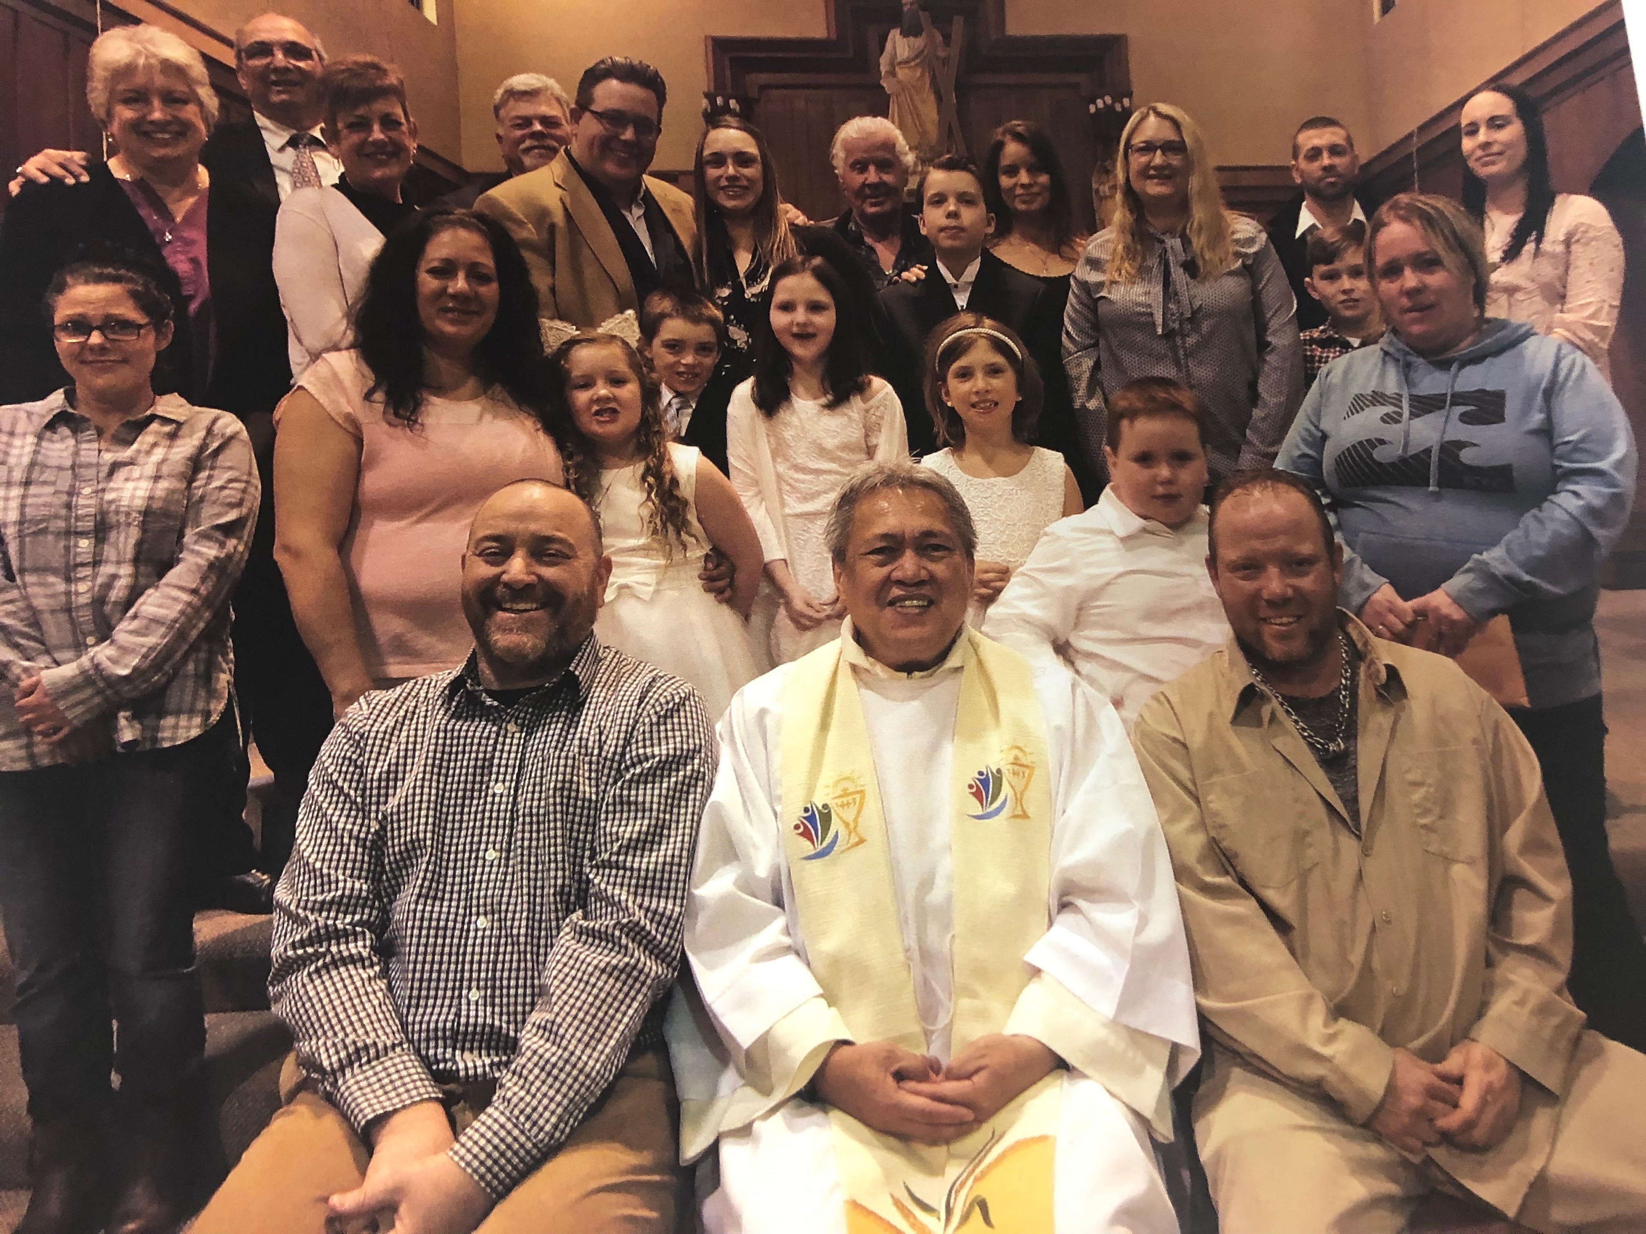

MAKERSPACE CLUB

Foley has a new MakerSpace Club that meets weekly during the lunch recess. MakerSpace is a place where students gather to create, explore and invent. As part of our new Learning Commons initiative, to include robotics, coding, new media and creative works (Green Screen, Lego, and Design Lab), the MakerSpace club is the first of many programs to demonstrate our school’s commitment to inquiry learning. Students will engage in learning skills that will help in solving real life problems. Students need not look elsewhere, their imagination is all they need!

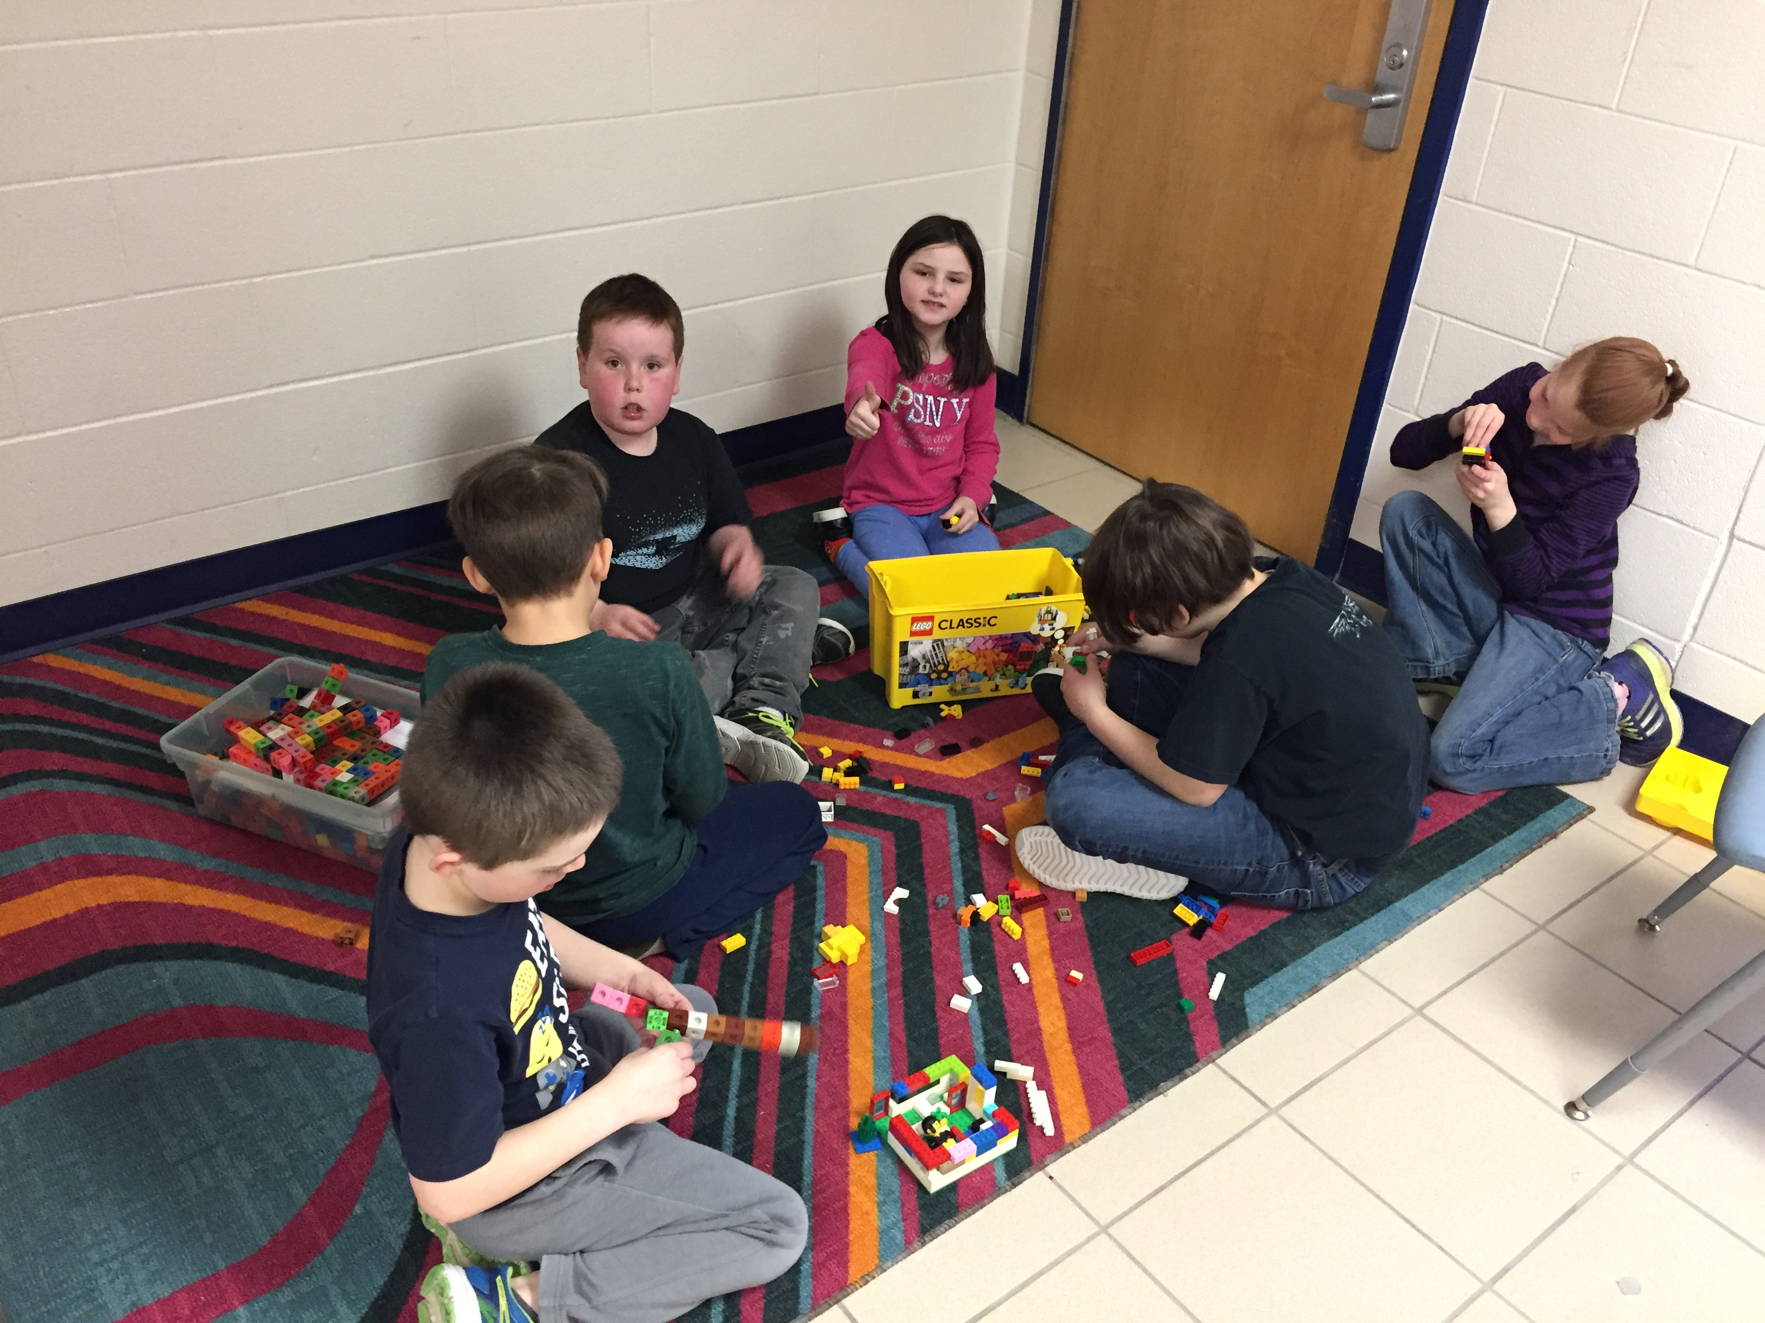

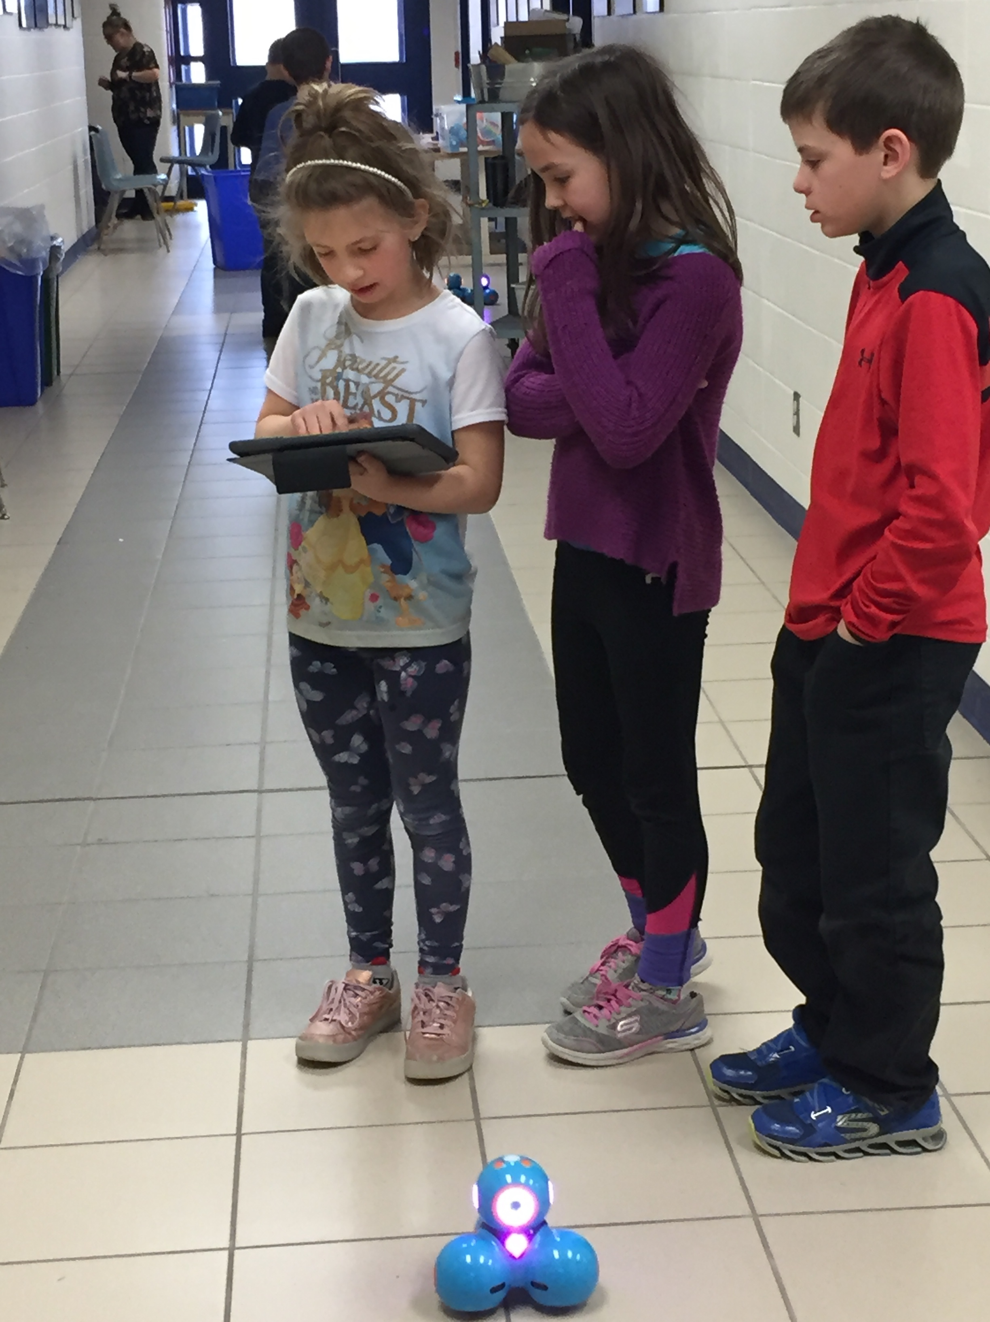
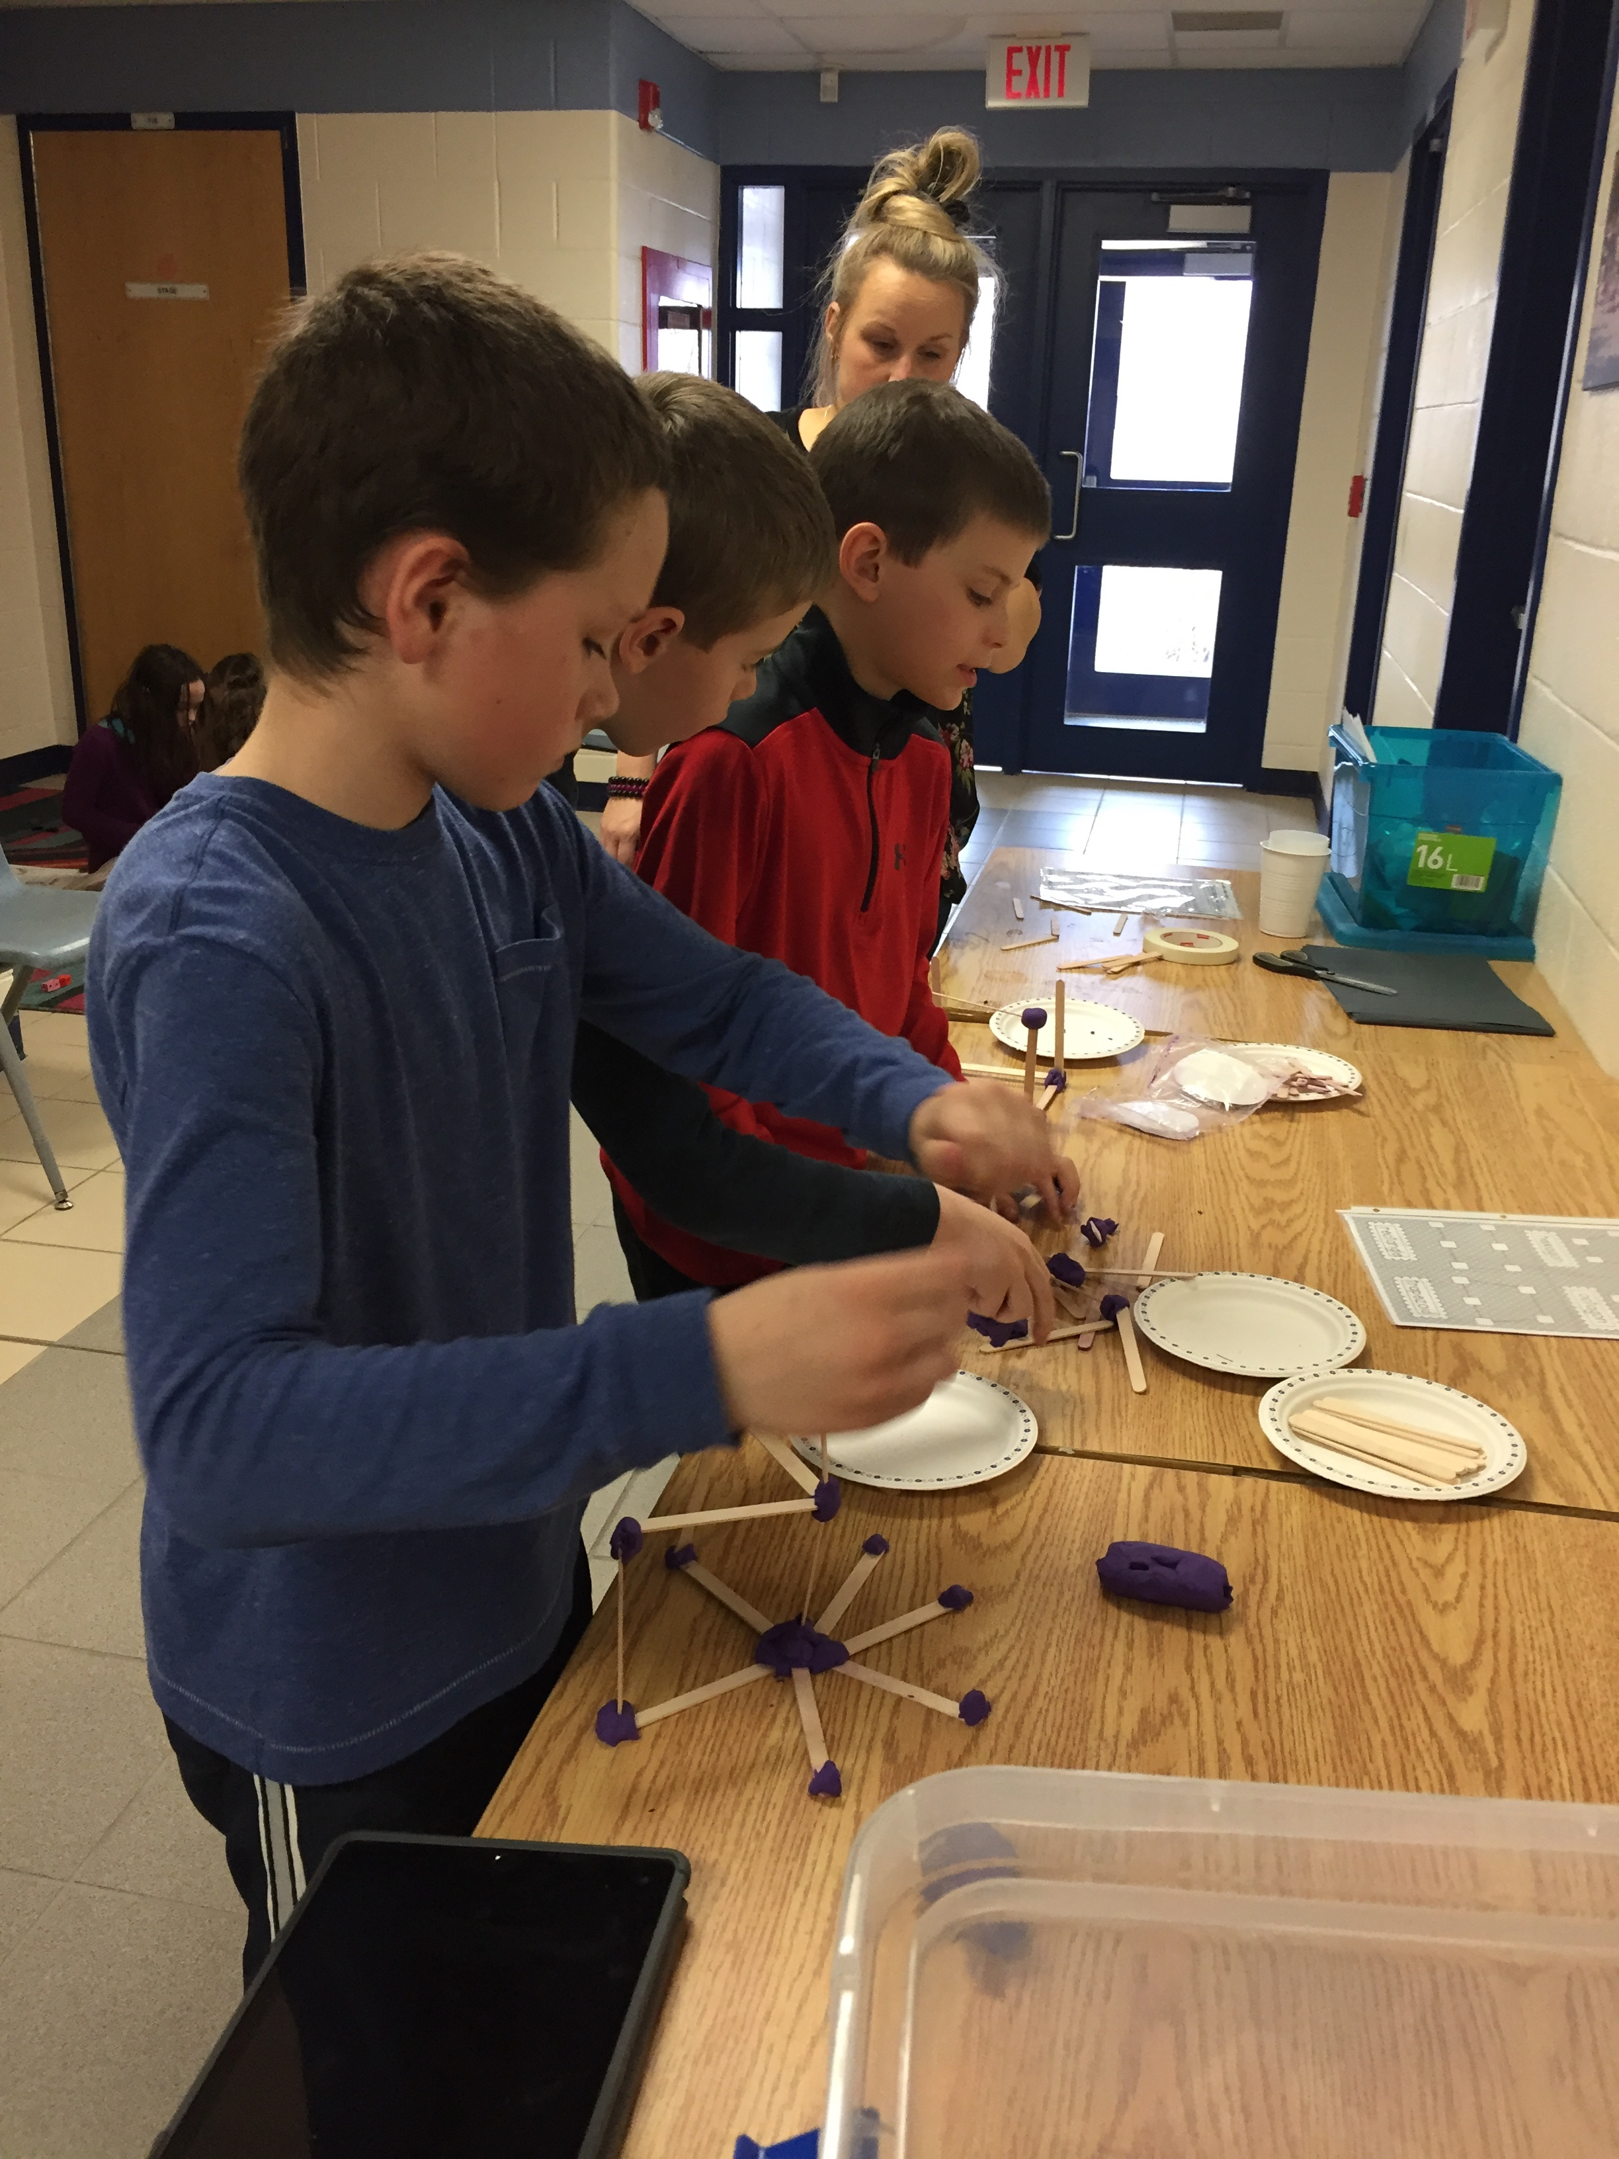

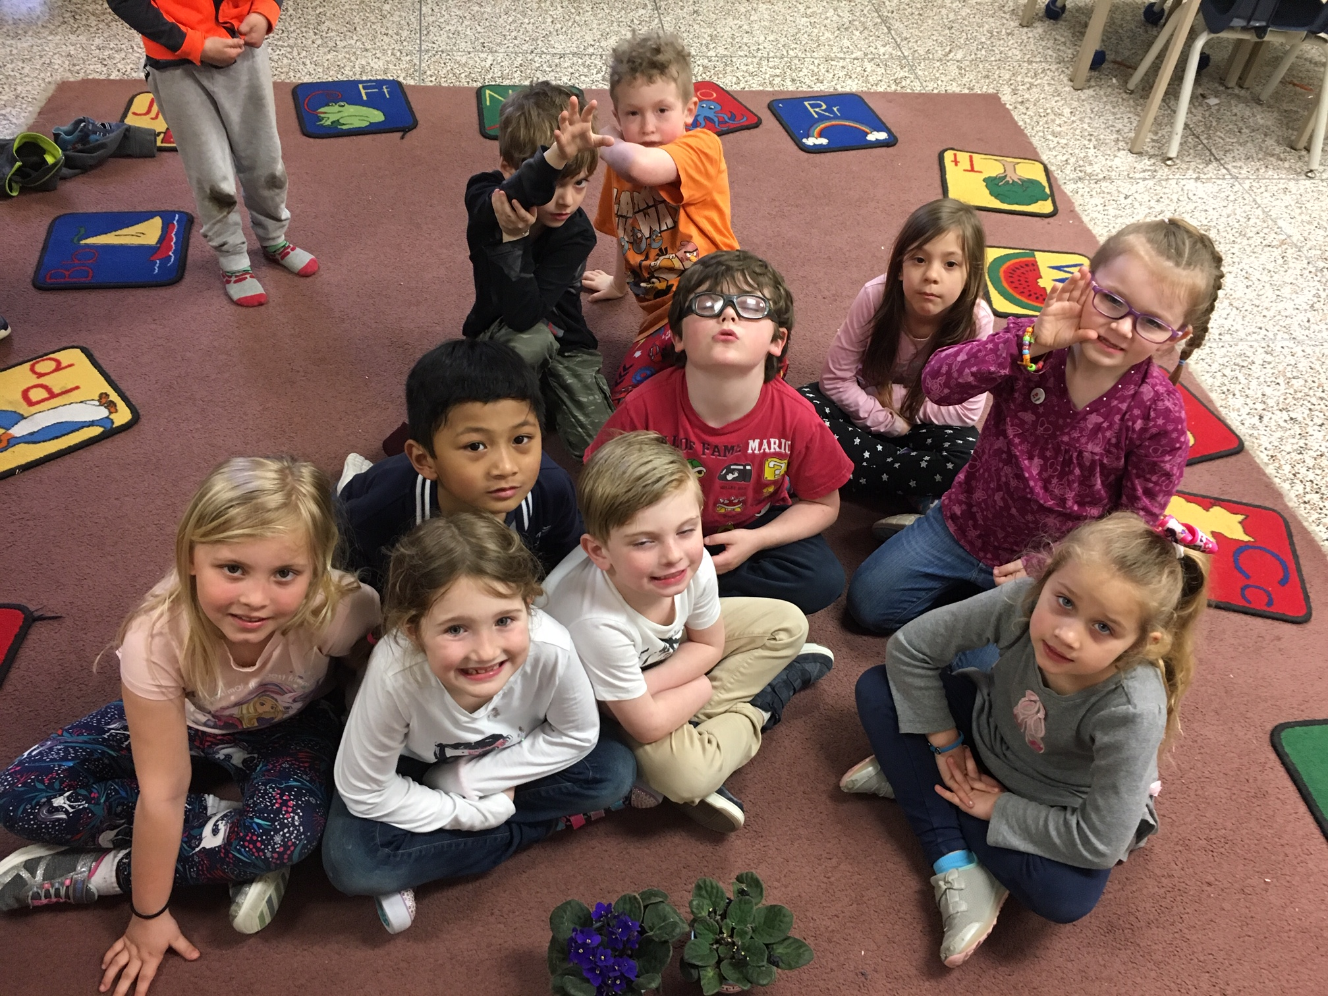
K-1 Science
We have been doing an experiment for the last month with 2 African violets.
One lived on the windowsill in the sun, the other hid in the cupboard. We tracked and recorded the results by counting the flowers on both plants each week.
Now, the sunlight African violet has 24 flowers and for the last 2 weeks the one in the cupboard has had no flowers at all! We learned the importance of plants having the sun’s energy.

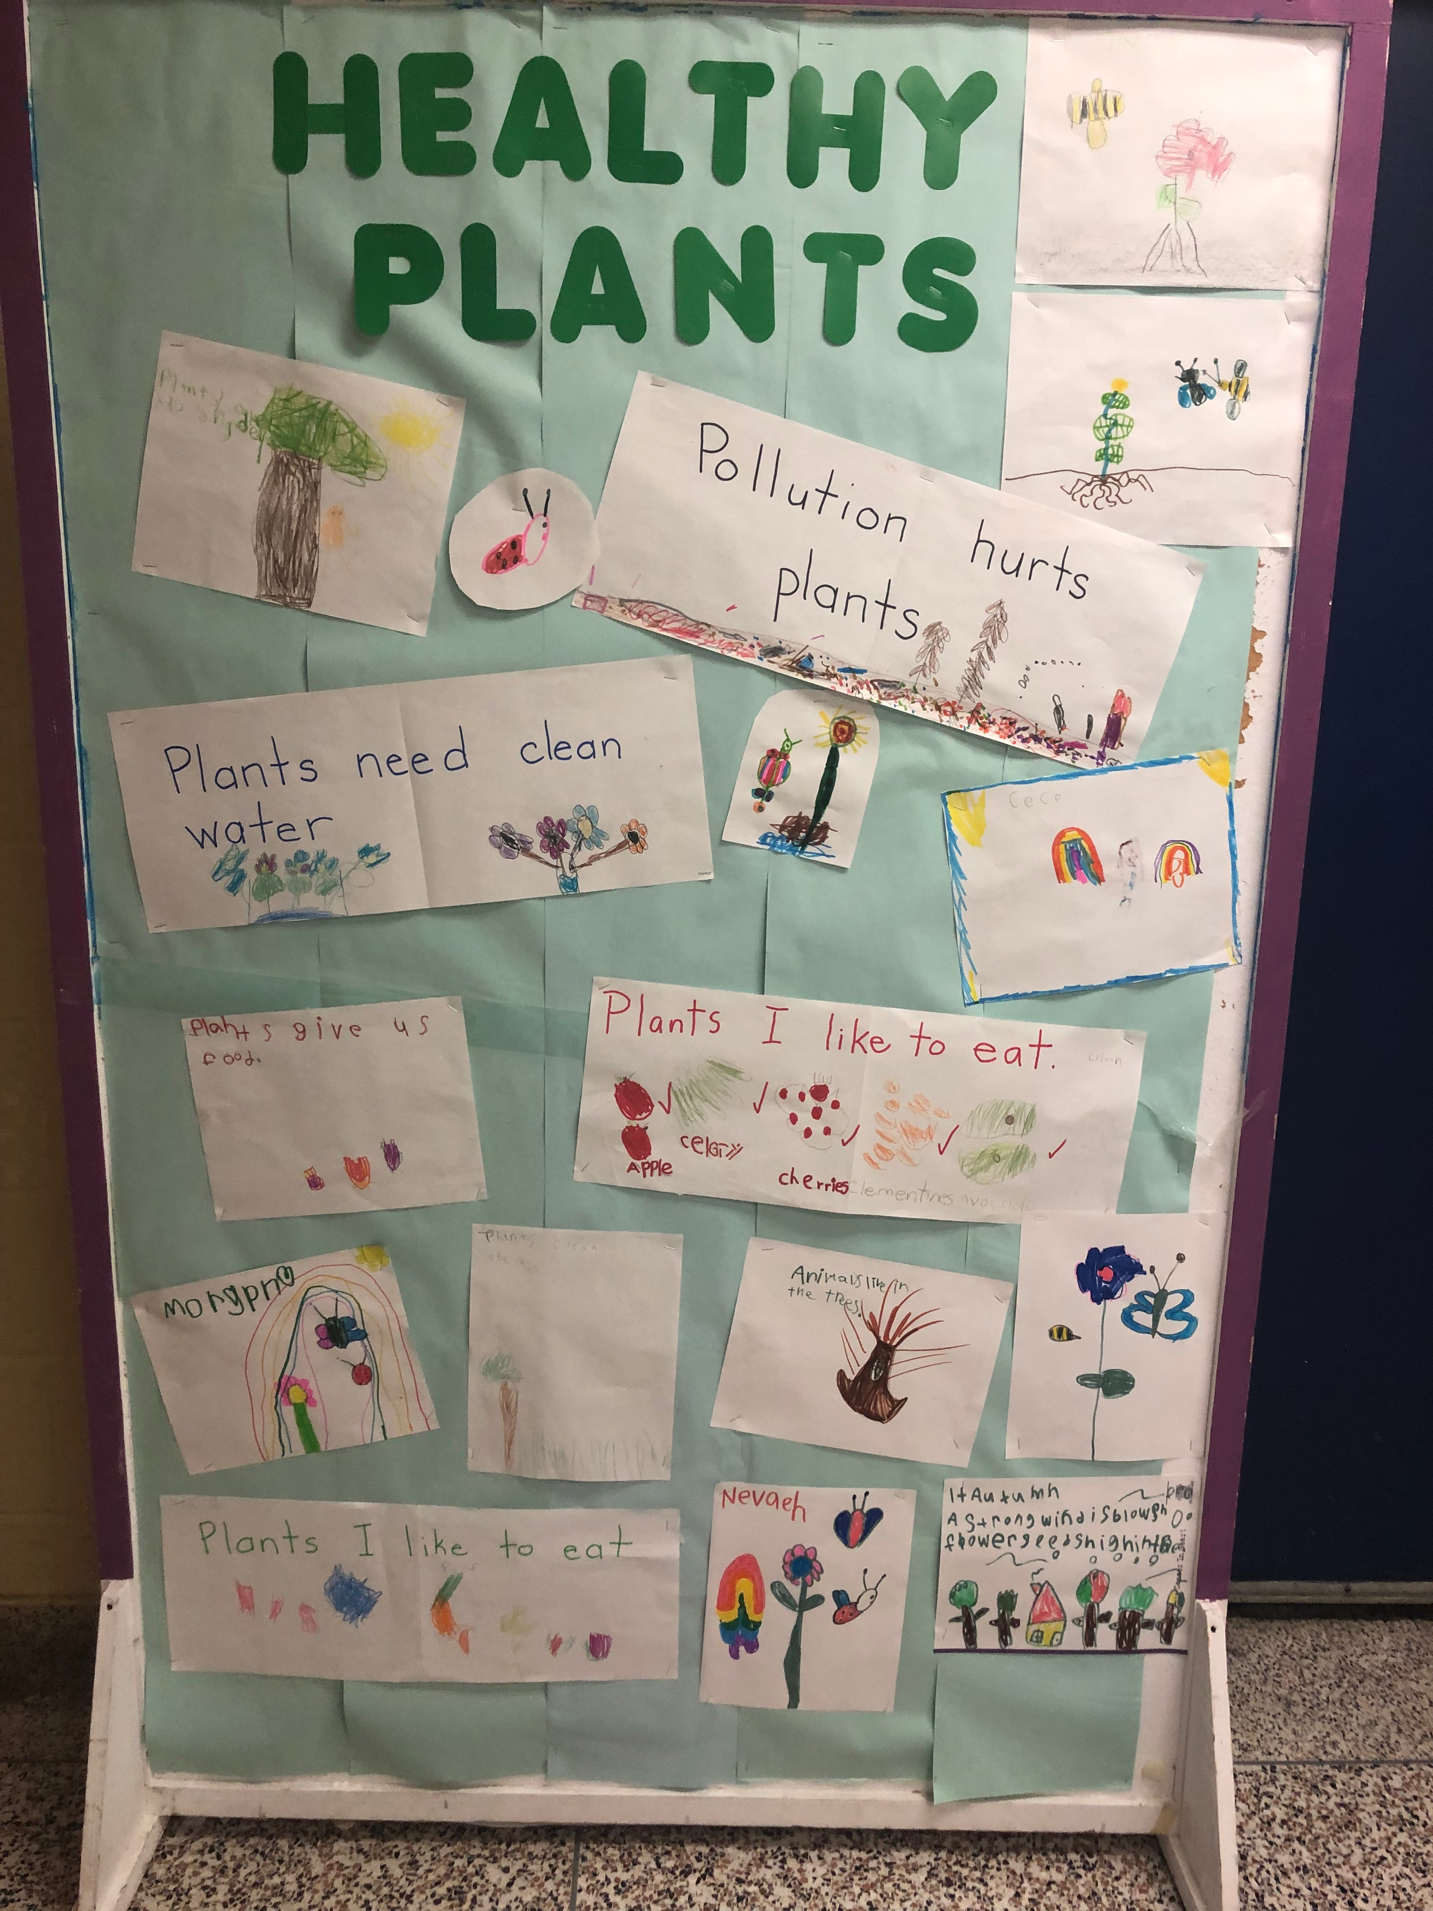
What started from an inquiry about a seed in a student’s apple, turned into Mrs. Robertson’s class bringing in different seeds to grow in class. The class learned the importance of plants.

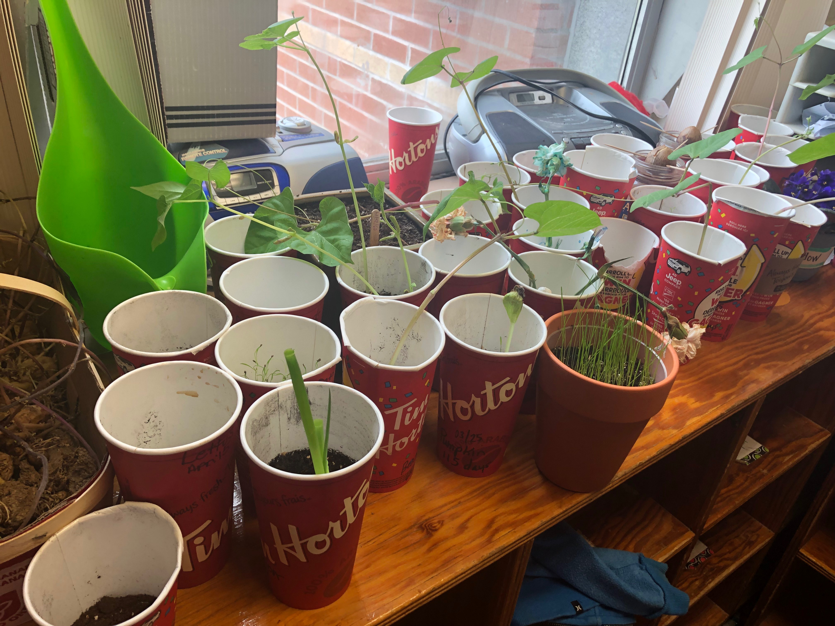

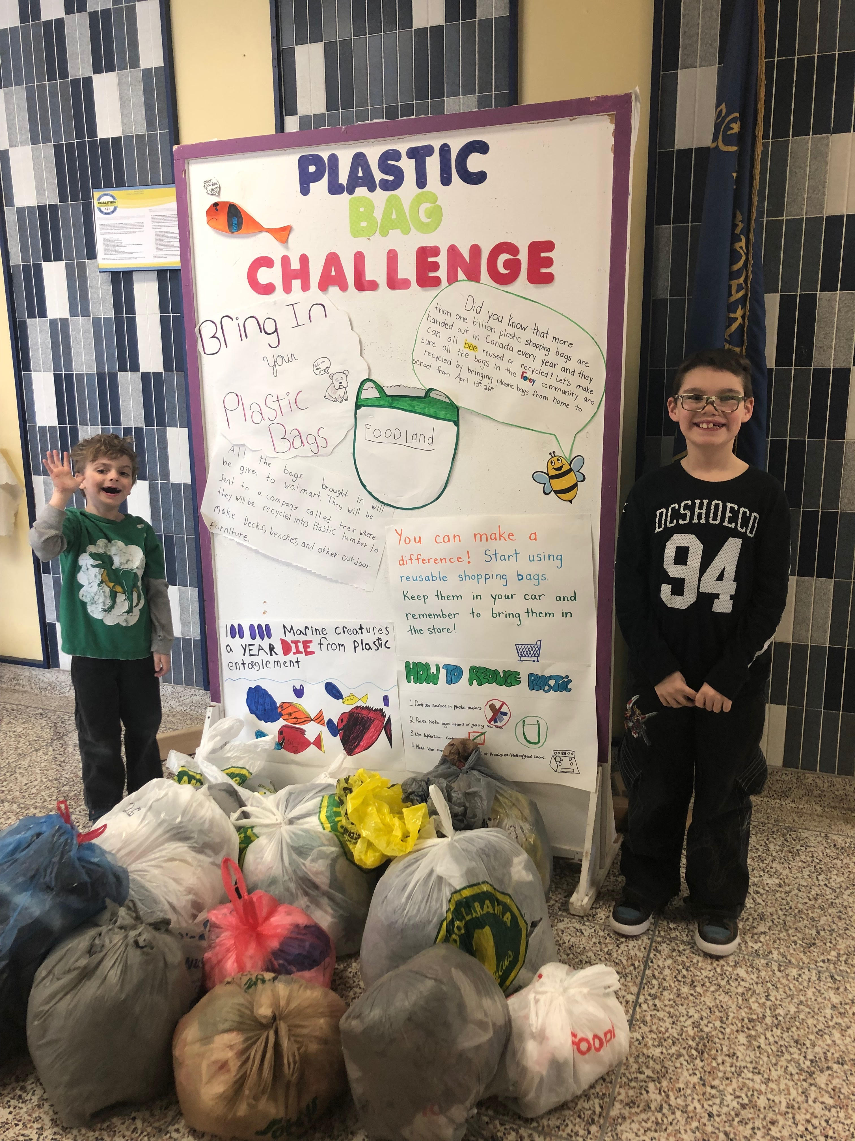
PLASTIC BAG CHALLENGE

Students and families from Foley have brought in quite a lot of plastic bags to the school to be recycled. We will bring the bags to Wal-Mart, who then sends them to a company that will convert the bags into plastic lumber used for decks, benches and other outdoor furniture. We can make a difference one small step at a time!

Head Lice (Pediculosis)

Like everywhere else, there are head lice in Simcoe County. You may have received a letter from school, or a phone call to give you a "lice alert." You may feel angry, afraid, frustrated or itchy. Head lice cannot spread any disease and have nothing to do with being clean.
Please make sure you are checking regularly for lice. If your child does have lice or nits, please contact the school and anyone your child has had contact with (babysitters, grandparents, etc.) to help stop them from spreading. This will help protect your child from getting lice again.

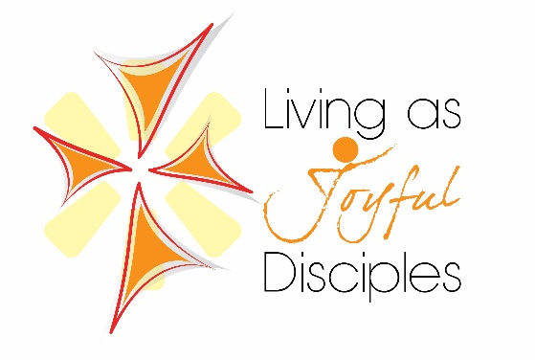

This year’s Catholic Education Week theme is “Living as Joyful Disciples.”

The 2019 theme was inspired by three sources: Renewing the Promise, The Pastoral Letter on Catholic Education from the Bishops of Ontario; Gaudete et exsultate, the Apostolic Exhortation of Pope Francis on the Call to Holiness; and Young People, the Faith and Vocational Discernment, the October 2018 Synod of Bishops. Mindful of the Synod on Youth, the theme and sub-themes are very much directed to the young people in our schools, especially in their growth in holiness and their formation as disciples of Christ through the discernment of their vocational pathways. In the section of Renewing the Promise entitled, “A Community that Forms Joyful Disciples,” we read, “Our Catholic schools help to form joyful disciples as hearts and minds are opened to the transforming love of God and to the flame of faith in action. On a daily basis, Catholic schools demonstrate the joy of believing and witness the Good News to the communities that they serve.”

There are five sub-themes for each day of Catholic Education Week:

Day 1: Rooted in Prayer
Enracinés dans la prière

Day 2: Living in Community
Vivre au coeur de la communauté

Day 3: Doing Justice & Creating Hope
Semer la justice et inspirer l’espérance

Day 4: Journeying Together in Faith
Cheminer ensemble dans la foi

Day 5: Sharing the Good News
Partager la bonne nouvelle

Every year, the Ontario Catholic School Trustees’ Association (OCSTA) provides our Catholic schools with a resource kit to help schools prepare for Catholic Education Week. Using these resources, as well as our own developed activities, we have prepared a series of activities, which will highlight how the students and staff at our school are Living as Joyful Disciples.

We hope to see many of you during our school celebrations.

STUDENT ASSEMBLY

Awards for a discerning Believer were handed out at the student assembly.

A Discerning Believer

I believe that God is an awesome God
I believe and have faith in God
I believe that God is with us always
I believe that we can talk to God anytime and anywhere through prayer
I believe in the stories in the Bible
I believe in the stories of Jesus’ life, death and resurrection
I believe in the Church community, celebrating Mass and the seven Sacraments
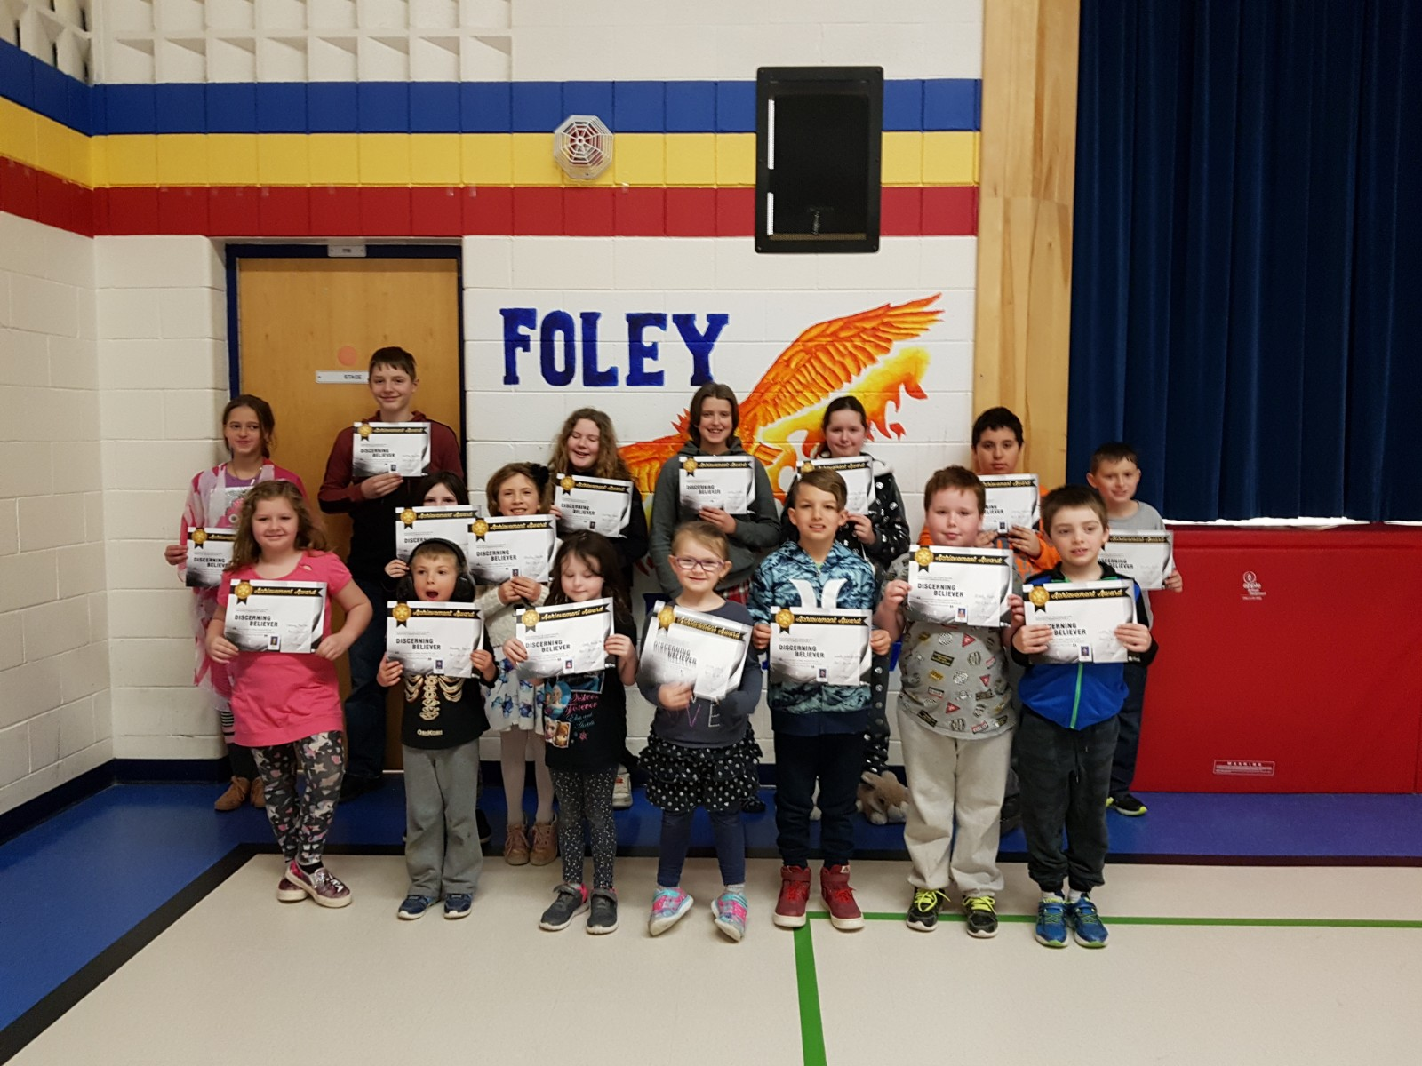

Mrs. Robertson and Ms. Pauze’s class – Erica, and Cece were awarded and also Brandon who was recently baptized.

Mrs. Turlej’s class – Sammy, Luke K., Ruby, Zachery, and Wade all received the Sacraments of Reconciliation and First Communion this month. They worked diligently in the preparation and we are very proud of each of you! Kayley was Baptised and received the Sacraments and First Communion.

Mrs. Shaw’s Class – Braydon was baptized, received the Sacraments of Reconciliation and had his First Communion.

Charlotte, Carole, and Cosimo all dedicated altar servers.

Mrs. Schug’s class – Courtney and Molly have volunteered to be altar servers at our Community of Schools Catholic Education Week Mass at Guardian Angels Church

Nathan enjoys listening to and playing Christian rock!

Congratulations to the many recipients!!

