Foley Catholic

School
MARCH 2019
https://fol.schools.smcdsb.on.ca

Principal: Ms. T. Moreau Office Administrator: Mrs. B. Gavin

PRINCIPAL’S MESSAGE

The March break is fast approaching and with that the promise that spring is around the corner! Our one sure sign of spring is Lent. On March 6th, we will be gathering as a school community to celebrate Ash Wednesday. Ash Wednesday marks the beginning of Lent. Lent is a time to focus on our relationship with God and is a 40-day period of preparation for Easter Sunday and one of the major seasons of the Catholic Church. Lent is a season of penance, reflection, and fasting, which prepares us for Christ’s Resurrection on Easter Sunday.

This year the March break is from Monday, March 11th to Friday, March 15th. I wish everyone a Happy St. Patrick’s Day and a very relaxing, restful and safe March break!

The EQAO Grade 3 & 6 Assessments of Reading, Writing & Mathematics are scheduled for May 21st to May 29th. Please mark these dates in your calendar and make every effort to avoid any trips, appointments, etc. during the week your son/daughter completes the Grade 3 or 6 EQAO Assessment. The specific week that the Grade 3’s are writing will be May 21 - 23 and Grade 6’s will be writing the assessment May 27 - 29.

I trust this Lenten season will strengthen your relationship with God. Just as winter promises us spring, God promises hope in the resurrection of his Son.

Ms. T. Moreau

Lenten Prayer
Loving Father,
I invite you into my life today
and make myself available to you.
Help me to become the-best-version-of-myself
by seeking your will and becoming a living example
of your love in the world.
Open my heart to the areas of my life that need to change
in order for me to carry out the mission
and experience the joy you have imagined for my life.
Inspire me to live the Catholic faith
in ways that are dynamic and engaging.
Show me how to best get involved in the life of my parish.
Make our community hungry for best practices
and continuous learning.
Give me courage when I am afraid,
hope when I am discouraged,
and clarity in times of decision.
Teach me to enjoy uncertainty and lead your Church
to become all you imagined it would be
for the people of our times.
Amen.

Upcoming Events

Mon. March 1 – Student assembly at
10 a.m. Mrs. Brookes will be
attending

Tues. March 5 – Shrove Tuesday

Wed. March 6 – Ash Wednesday
Mass at 10am at St. Andrews

Thurs. March 7 – Speeches at the
Legion at 6:30 p.m.

Intermediate Math Olympics

Mon. March 11 – March Break Begins

Mon. March 18 – Back to School

Thurs. March 21 – Down Syndrome Day
Wear your crazy socks!

Tues March 26 – World Epilepsy Day
Wear Purple

Kindergarten Information Night 5:30-7:00

Fri March 29 – Junior Math Olympics

Sat. March 30 – First Communion at
4 p.m. Mass

The 100th Day of School

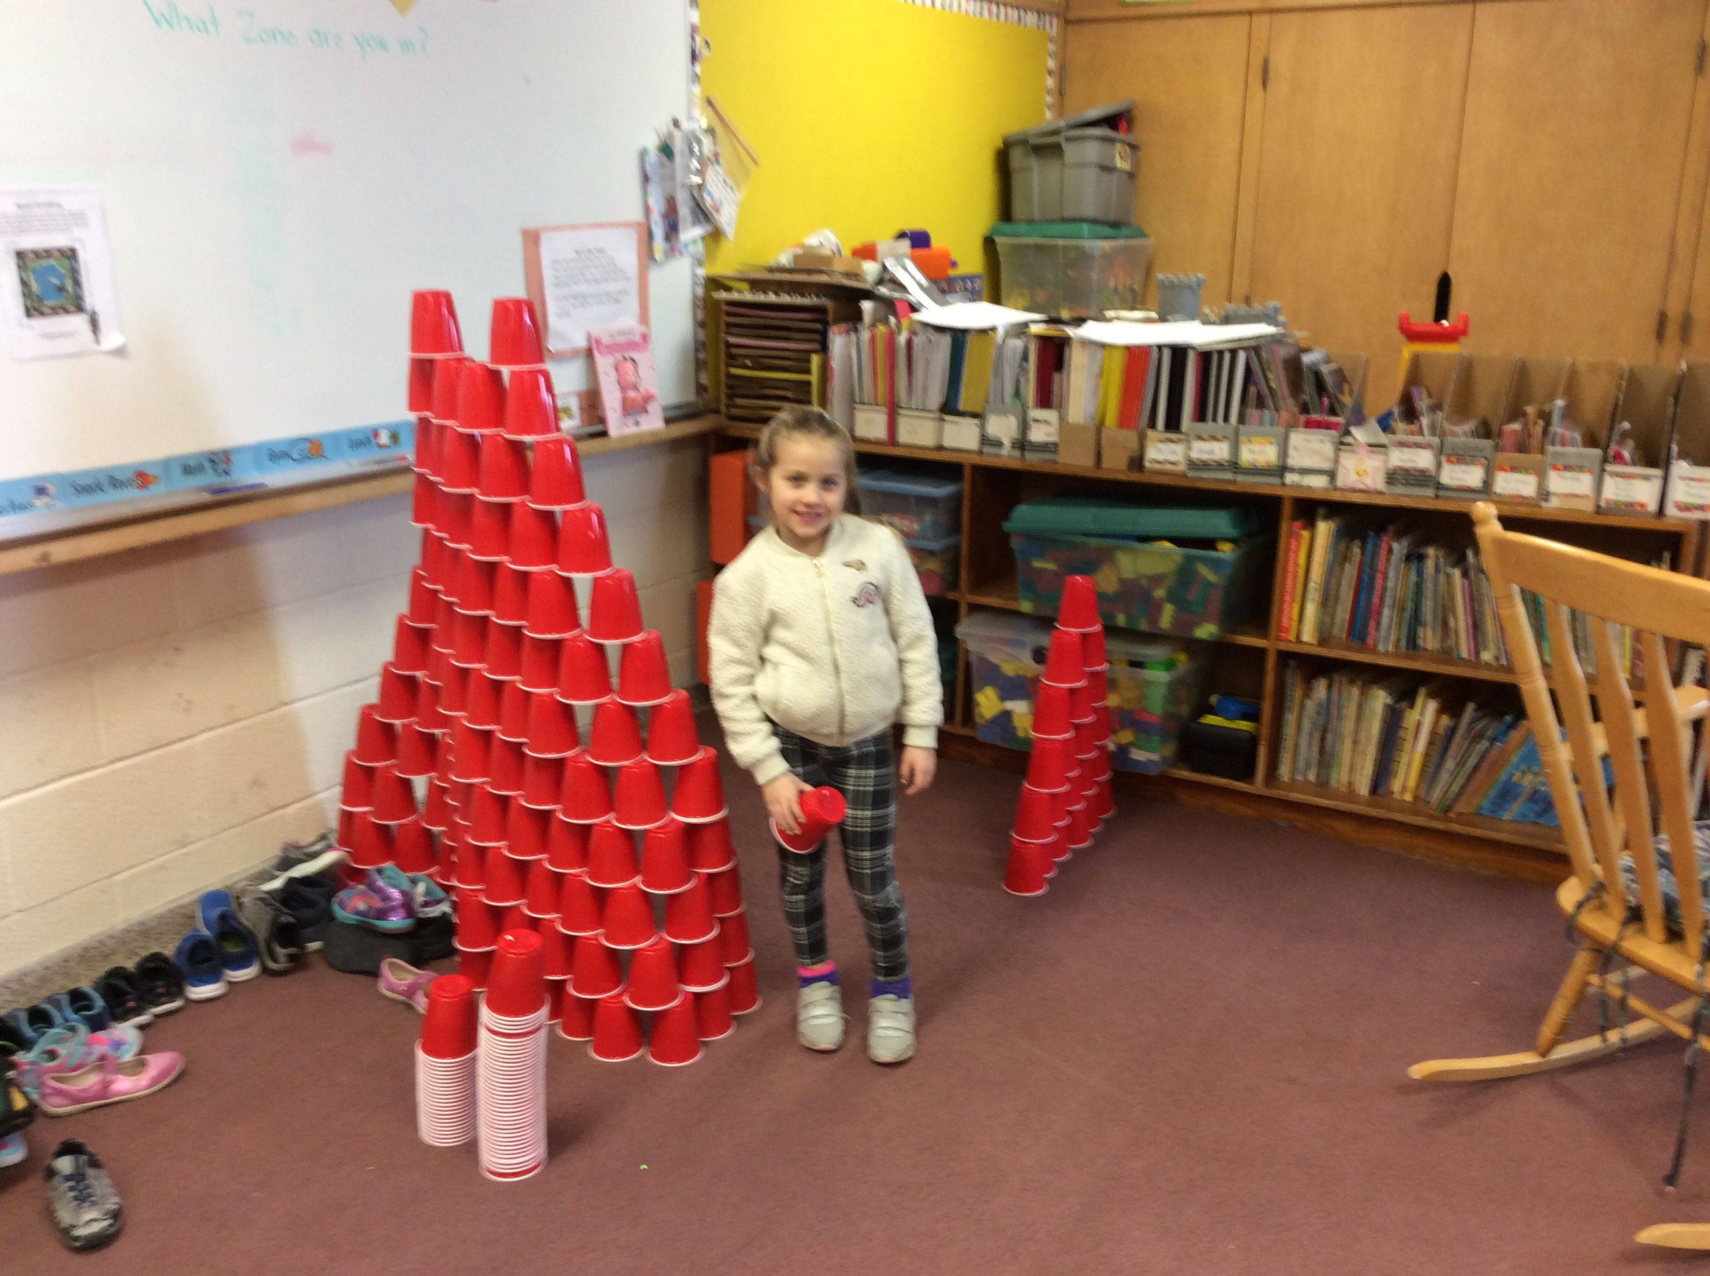
Mrs. Robertson’s JK/SK/1 class celebrated the 100th day of school on Monday, February 11.

They learned about different ways to make 100. The best part of the day was when they got to make towers and buildings using 100 cups!

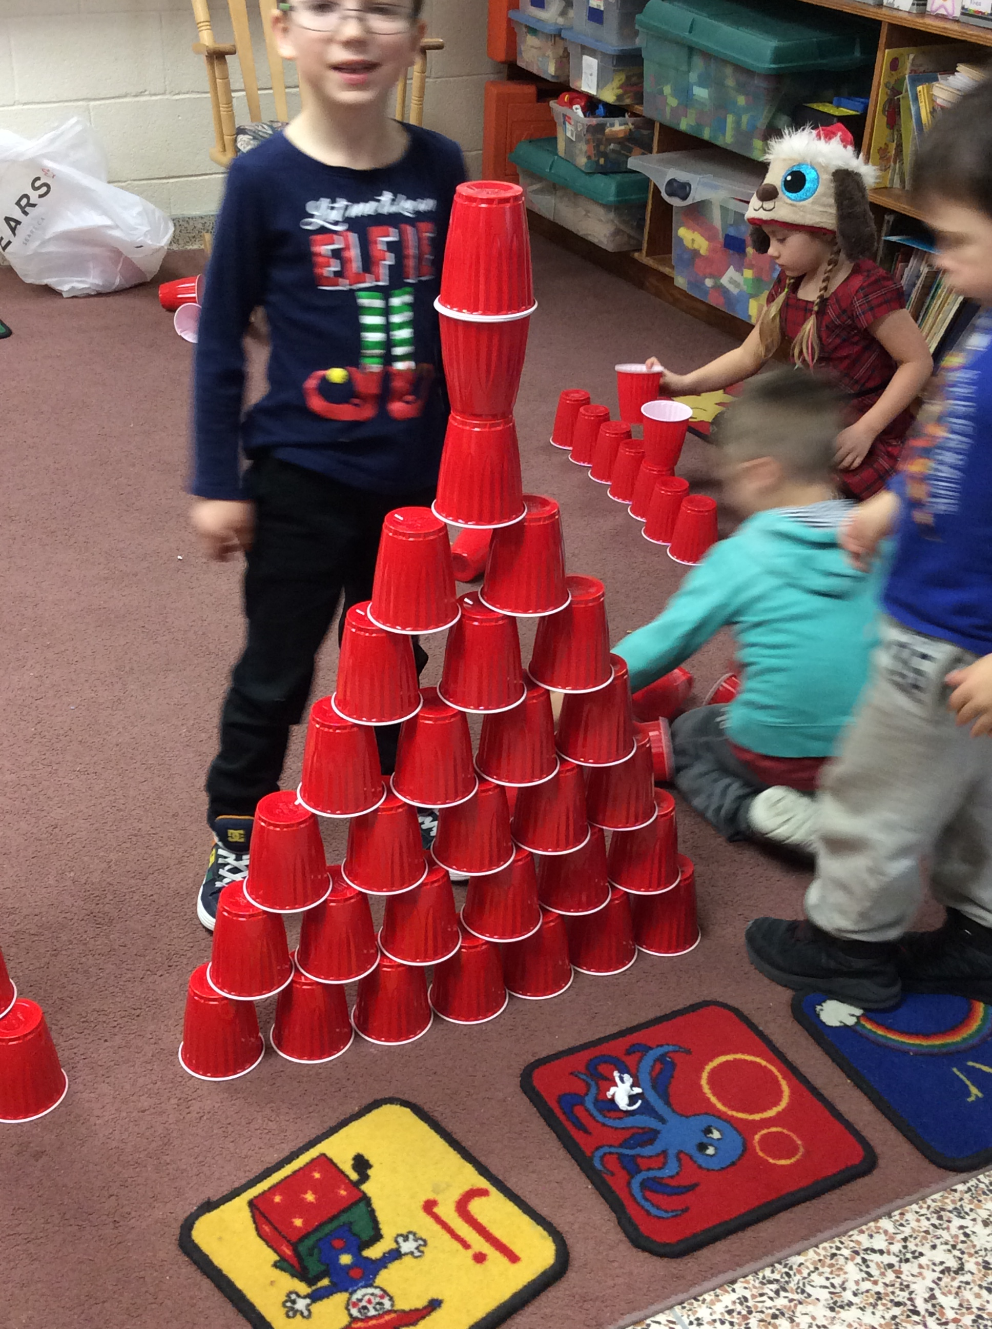

Talent Show

Students planning on trying out for the Talent Show need to sign up in the hallway as soon as possible. Try-outs will be held the week before the March Break.

Family Day Mass

Many thanks to the following students and their families who were able to come to the Family Day weekend mass at St. Andrew's. Cosimo, Molly, Olivia S, Ian S and Carole covered all the readings as well as all of the music. Please note that on March 17th, Mme Tammy will not be there to lead the choir because it will be March Break.

SCHOOL-DAY
We are implementing a new online payment and communications tool in our schools. This tool, called “School-Day”, will be available at your school beginning April 2019.

Benefits for parents?

School-Day can be accessed from any web browser and gives parents real-time, secure access to up-to-date information, and the ability to:

- Receive email communications from your child’s school
- Approve permission forms on-line
- Register your child for extracurricular events
- Make online payments for yearbooks, student cards, sports fees, trips or other activities
- Update your mobile device with calendar events specific to your child
- Minimize the risks associated with sending money to school with your child (“backpack delivery”) and reduce the environmental impact of photocopying permission forms and announcements
We are excited to offer our parents this efficient and convenient tool and are asking parents to consider signing up for School-Day. For more information registering for School-Day, please contact your school or visit www.school-day.com.

Dance-A-Thon

The students here at Foley had a wonderful afternoon at their Dance-A-Thon. We would like to thank all of the families and friends for your support. The proceeds will go towards a laminator as well as some much needed art supplies.

Welcome to Kindergarten
Do you know a child turning 4 in 2019? If so, it's time to register for Kindergarten! Please contact Foley Catholic School directly to find out more information.
The school will provide you with a Kindergarten Welcome Package. Please visit our Registration Page to learn more about the required information and documentation to register you child.
Our Kindergarten Information night is Tuesday March 26 from 5:30-7pm. We look forward to meeting you!

