Subscribe to Our Online Backpack!

Our online backpack tool allows parents to download lunch order forms, permission forms and other important documents directly from our website. To receive notifications when a new document has been added, please follow the steps below to subscribe.

Go to our school website and click on “Online Backpack”

To receive notifications for ALL documents, click on “Subscribe” at the top.

To subscribe to a specific folder, click on the three dots beside the folder and click “subscribe.”

Enter our school name as the title, your email address, and select how often you would like to be notified (immediately, daily or weekly).

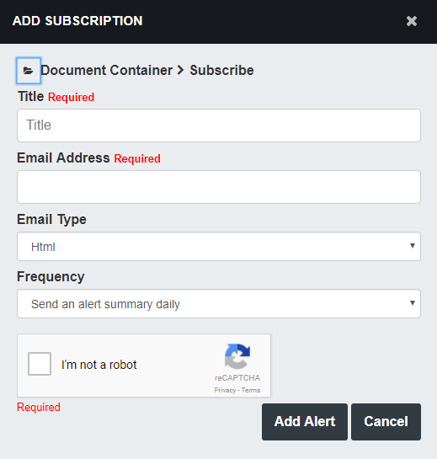

You may unsubscribe anytime directly from your email notifications.

