Foley Catholic Elementary School
2162 Concession Road 4
Brechin, Ontario
L0K 1B0

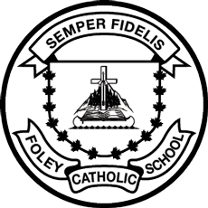

PARENT COUNCIL

CENTREPIECES FUNDRAISER

ORDERS DUE: THURSDAY, DECEMBER 6, 2018

DELIVERY DATE: WEDNESDAY,
DECEMBER 12TH, 2018 (2-5 PM)

